Sunday 3rd November

Microcredit loan results within the ISIAT project adapting social protection to people living with TB
Jason P Kahn¹, F Concha², C Rocha^{1,5}, R Montoya¹, W Ynga¹, MA Tovar¹, Delia Boccia³, Carlton A Evans^{1,4}
- IFHAD: Innovation for Health And Development, Universidad Peruana Cayetano Heredia, Lima, Peru
- Microfinanzas PRISMA, Lima, Peru
- Faculty of Epidemiology & Population Health, Dept Infectious Disease Epidemiology, London School of Hygiene and Tropical Medicine
- Section of Infectious Diseases & Wellcome Centre, Imperial College London, UK
- Naval Medical Research Unit No 6, Lima, Peru

Background: Microcredit loans have been used in diverse settings to reduce poverty, which confounds TB control. However, the role of microcredit loans in people affected by tuberculosis (TB) is undefined. We aimed to evaluate microcredit loans for impoverished TB-affected households.
Methods: The study was part of the Innovative Socioeconomic Interventions Against TB (ISIAT) project in Lima, Peru that partnered with an established microcredit organisation. Participating clients were given a schedule for loan repayments and late payments were subject to extra charges. Socio-demographic data including education level and poverty status were recorded during a baseline visit.
Results: The population was poor, with 22% (64/297) of households living on less than $1 per person per day. For people living with TB, group loans were difficult to implement and were gradually replaced by individual loans. 21% (62/297) of TB-affected households borrowed 117 loans. Access to these loans appeared to be equitable because households that borrowed tended to have lower income, spending, schooling and be more crowded than households that did not borrow. Another 27 households that were not TB-affected also borrowed 34 loans. Of these total 151 loans, 36% (55) defaulted. Factors associated with default are shown in the Figure: the borrower being male (RR=2.0, p<0.02), living in a TB-affected household (RR=1.4, p<0.001), and the loan being larger (p<0.001). Default rates were not associated with schooling completion, income, spending, crowding or loan multiplicity (all p>0.1). Of the total $83,035 loans ($67,326 capital borrowed plus $15,710 scheduled interest and charges), 49% ($40,730) defaulted, including $23,656 in additional charges for late repayments. The ISIAT project facilitated debt cancellation.
Conclusion: Microcredit loans were accessed equitably by TB-affected households. However, microcredit was difficult to adapt to try to help impoverished people living with TB. Stigma hampered the village-banking group loan process necessitating individual, personal loans. Loans to 41% of TB-affected households left them indebted. These results suggest that microcredit loans should be offered to TB-affected households only with caution, careful selection and support. Loan success rates may be improved by targeting specific demographic groups including women, and by providing smaller loans.

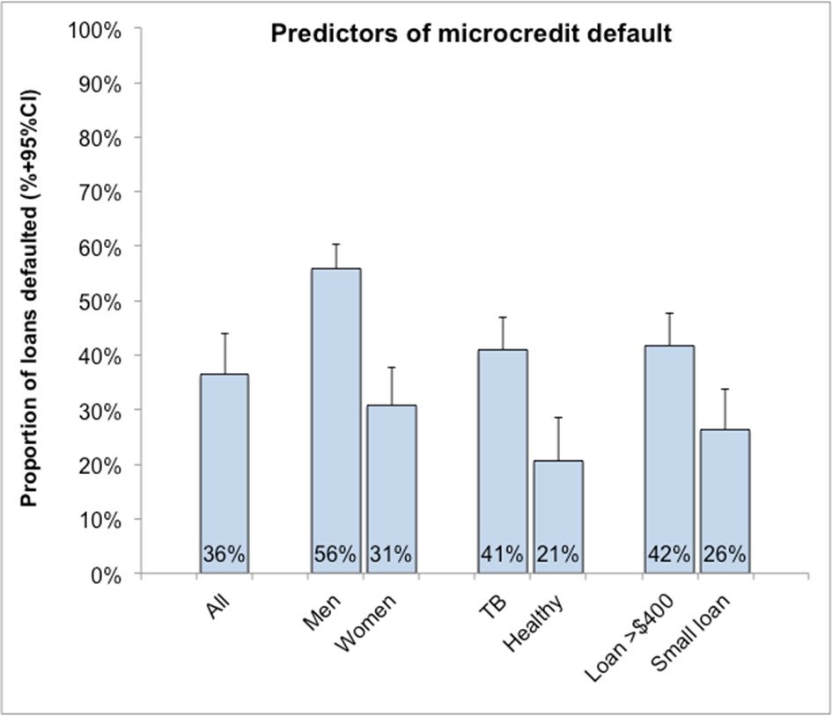

Reference of your abstract and your poster board | PC-872-03
Title of your abstract | Microcredit loan results within the ISIAT project adapting social protection to people living with TB
Type of session | Poster Discussion session
Title of session | 52. Community issues in TB control
Date, time and place | Sunday, 3 November 2013 from 12:45 to 13:45

